**About Mobilse Twitionary AI-Driven Platform**

Twitionary is artificial intelligent powered crowdsourcing platform to collect data from different resources based on provided keywords Twitionary analyze collected data and perform sentiment analysis

**Source of Data collection**

* National/international News sites
* Blogs sits
* Twitter

**Features**

* Addition/deletion of key words for data collection
* Scrape data from 500+ national/international sites,
* Scrape more then 400,000 ( four hundred thousands) record per day
* Scape English/Urdu news
* Archived record since February 2020
* Scape 150,000 tweets per day
* Perfume sentiment analysis on every record
* Statically/Graphically view of performed analysis

**How it works**

Based on provided data dictionary (user can update dictionary) twitionary Scrape Data from different national/international news, blog sites and twitter, it stored the scraped data in Database

Based on scrape data Twitionary ML module perform sentiment analysis, the platform is hosted on Google cloud server <http://34.68.136.134/blog/>

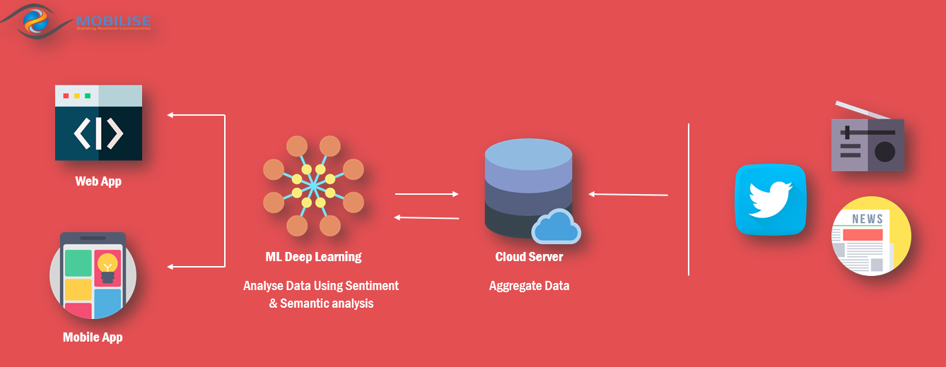

**Purpose of mobiles twitionary platform**

* Reduce manual work
* Improve organization media campign for public awarnes
* Real time data avilibity
* help in decision making

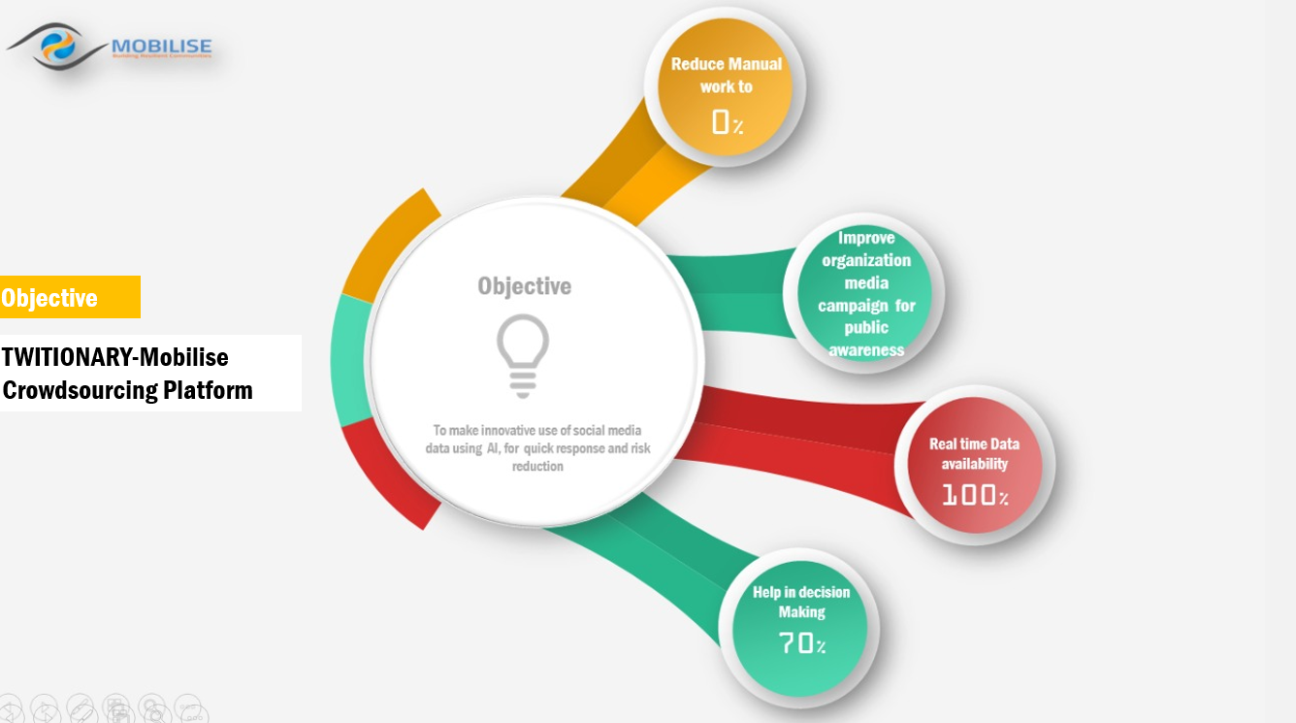

**Status of application**

Web application is fully functionally hosted on Google cloud platform <http://34.68.136.134/blog/>

Using above Server IP address

**What are the next steps?**

* Add Statically/Graphically analysis based on scape data
* Currently the platform is hosted on free space provided by Google cloud platform(GCP), the server has limiteation this need to be hosted on proper server
* For now we can access using IP address a proper domain need to be purchased
* After testing and finalization of platform a cross mobile application need to be developed